**ASP.NET MVC 4 Hands On Lab**

**Part 3: Adding Controller(s)**

Let’s begin our MVC Music Store application by adding a Controller class that will handle URLs to the Home page of the site.

1. Right-click the **Controllers** folder within the Solution Explorer & choose **Add**🡪**Controller** as shown below:

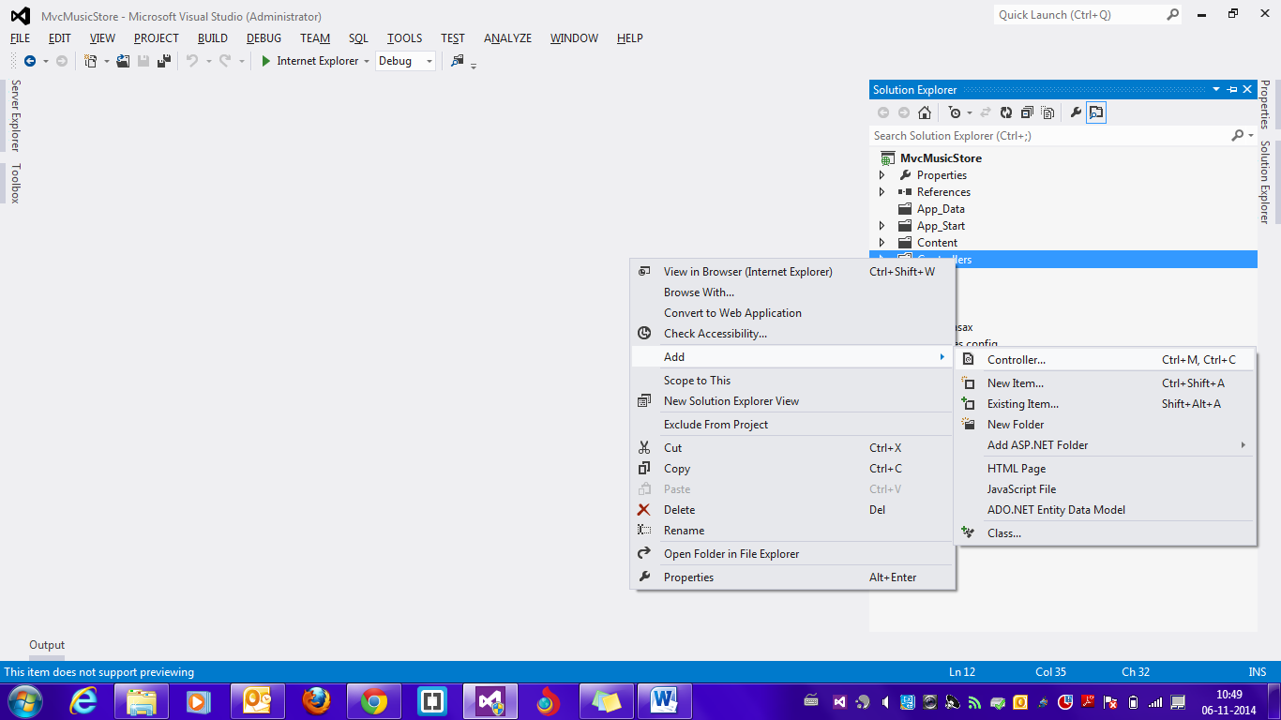

1. In the **Add Controller dialog,** type the controller name as **HomeController** & click **Add** as shown below:

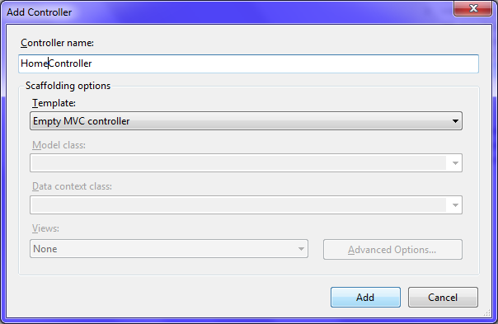

1. To make things simple initially, delete the **Index()** method inside the **HomeController** class & write the following code inside the **HomeController class:**

public string Index()

{

return "Hello from Home";

}

1. Run the application by pressing **F5.** The output should look as shown below:

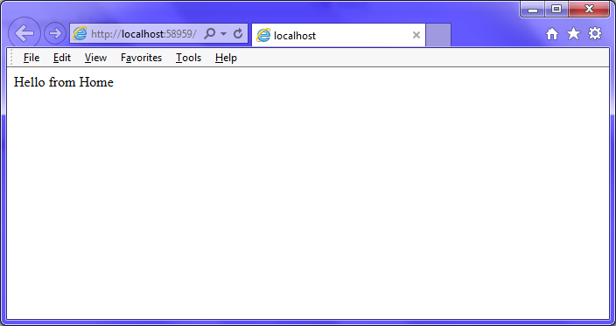

1. Add another controller named **StroreController** as mentioned in step 1 & 2 .

**This controller will support 3 scenarios:**

1. **A listing page of the music genres in our music store (Index() action)**
2. **A browse page that lists all of the music albums in a particular genre (Browse() action)**
3. **A details page that shows information about a specific music album (Details() action)**
4. Delete the existing code inside the **StoreController** class.
5. Add the following code inside the **StoreController** class:

public string Index()

{

return "Hello from Store.Index()";

}

public string Browse()

{

return "Hello from Store.Browse()";

}

public string Details()

{

return "Hello from Store.Details()";

}

1. Run the application by pressing **F5.** Append the following after the URL in the address bar of the browser respectively to invoke the action methods & observe the results:

**/Store**

**/Store/Browse**

**/Store/Details**

**Let’s now make the action methods dynamic, so they take information from the URL & display it in the page output.**

1. Modify the **Browse()** & **Details()** action method inside the **StoreController** class as shown below:

public string Browse(string genre=”disco”)

{

string message = "Store.Browse(), Genre = "+ genre;

return message;

}

public string Details(int id=0)

{

string message = "Store.Details(), ID = " + id;

return message;

}

1. Run the application by pressing **F5.** Append the following after the URL in the address bar of the browser respectively to invoke the action methods & observe the results:

**/Store/Browse?genre=Disco**

**/Store/Browse/Disco**

**/Store/Details?id=5**

**/Store/Details/5**